**Sprint backlogs**

|  |  |  |  |  |  |
| --- | --- | --- | --- | --- | --- |
| No | Product backlogs | Tasks | Tasks Owner | Estimate time (hour) | Hours of work |
| 1 | As a student, I want to be able to submit one or more ideas. | 1. Create the draft user interface | Cecillia | 1 | 1 |
| 1. Design the user interface | Cecillia | 1 | 1 |
| 1. Create a database | Dharshini | 1 | 1 |
| 1. Code the function | Dharshini | 1 | 1 |
| 1. Test the function | Cecillia | 1 | 1 |
| 2 | As a user, I want all the ideas to be categorized. | 1. Update the user interface design of idea page | Cecillia | 2 | 1 |
| 1. Code the function | Dharshini | 2 | 2 |
| 1. Test the function | Cecillia | 1 | 1 |
| 3 | As a student, I want to be able to upload documents to support the ideas. | 1. Modify the database | Dharshini | 2 | 1 |
| 1. Update the idea page | Dharshini | 1 | 1 |
| 1. Test the function | Cecillia | 1 | 1 |
| 4 | As a student, I want to be able to agree to the Terms and Conditions before submission. | 1. Modify the design of idea page | Cecillia | 1 |  |
| 1. Code the function | Dharshini | 2 | 1 |
| 1. Test the function | Cecillia | 1 | 1 |

**Sprint backlogs**

|  |  |  |  |  |  |
| --- | --- | --- | --- | --- | --- |
| No | Product backlogs | Tasks | Tasks Owner | Estimate time | Hours of work |
| 1 | As a QA Manager, I can add additional categories and delete categories so that if they have not been used. | 1.Design the user interface | Cecillia | 1 | 1 |
| 2.Code the function | Dharshini | 2 | 2 |
| 3.Test the function | Cecillia | 1 | 1 |
| 2 | As a user, I want to post my ideas and comments anonymously and the author’s details will be stored so that any inappropriate ideas can be investigated. | 1.Code the function | Dharshini | 1 | 1 |
| 2.Test the function | Cecillia | 1 | 1 |
| 3 | As a QA coordinator, I want to view the list of ideas in paginated. | 1.Code the function | Dharshini | 1 | 1 |
| 2.Test the function | Cecillia | 1 | 1 |
| 4 | As a staff, I want to view the Lists of Most Popular Ideas (+1 for Thumbs Up, -1 for Thumbs Down), Most Viewed Ideas, Latest Ideas and Latest Comments. | 1.Code the function | Dharshini | 1 | 1 |
| 2.Test the fuction | Cecillia | 1 | 1 |
|  |  |  |  |

**Sprint backlogs**

|  |  |  |  |  |  |
| --- | --- | --- | --- | --- | --- |
| No | Product backlogs | Tasks | Tasks Owner | Estimate time | Hours of work |
| 1 | As a QA coordinator, I want to view the list of ideas in paginated. | Code the function | Dharshini | 1 | 1 |
| Test the function | Cecillia | 1 | 1 |
| 2 | As a staff, I want my comments to be visible to other staff only and view the students and staff comments. | 1.Code the function | Dharshini | 1 | 1 |
| 2.Test the function | Cecillia | 1 | 1 |
| 3 | As a user, I want an interface which suitable for all devices | 1.Design interfaces | Cecillia | 1 | 1 |
| 2.Code the function | Dharshini | 1 | 1 |
| 3.Cecillia | Tester | 1 | 1 |

|  |  |  |  |  |  |
| --- | --- | --- | --- | --- | --- |
| 4 | As the University, I want to assign a Quality Assurance Manager in order to oversee the process. | 1.Code the function | Dharshini | 1 | 1 |
| 2.Test the function | Cecillia | 1 | 1 |
| 3.Update QA manager functions | Dharshini | 2 | 2 |
| 4.Test the function | Cecillia | 1 | 1 |

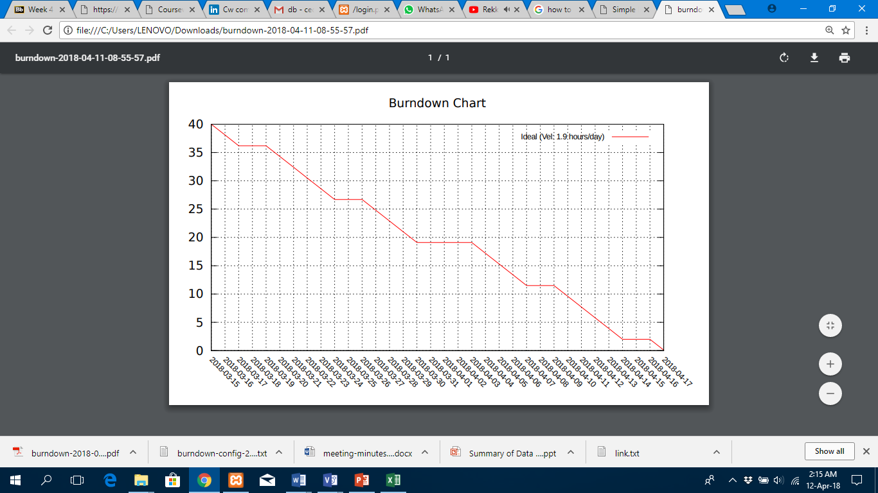

Chart 1 : Burndown Chart